Observations on the Evolution of the Recycling Industry & State Recycling Organizations in the US: Rites of Passage and Stages of Engagement
Wynne Coplea, President, IL Recycling Association
March 9, 2015

A brief overview of recycling in historical context: our culture and economy has moved from the
Conservation movement to the >>Environmental movement to the>>Sustainability movement, each of which include/d recycling as an activity based on values and set of organized programs based on economic viability. (Debatable: is recycling actually the grandmother of Sustainability? Recycling is
the #1 conscious conservation action taken by people worldwide!)

In about four or five decades, recycling has grown from being a small, cottage industry with niche services to being society-wide, economically viable and self-supporting, with some traditional hauler-community entrepreneurs either completely switching business models or crossing-over services for value-added operations. We have deep roots both in our culture and in our economy. (Note the recent switch of name from NSWMA National Solid Waste Management Assn to NWRA National Waste & Recycling Association -this is nationally significant.)

During this same time period, the recycling industry has spawned an entire language and lingo. What terms we use, why/how we use these related words really does impact perceptions and attitudes, both within and outside of the industry. Perceptions, matter - language can inspire to action and make folks feel a part of something, or can ostracize and generate angst…language can carry baggage (e.g. “green”.)

Recycling has been tucked officially within the Solid Waste Management Hierarchy in federal and state laws. We all remember the old, well-known graphic image of the SWM Hierarchy triangle; the flipping of this symbol and renaming of it (as some have officially done) to a Sustainable Resource Management or Sustainable Materials Management hierarchy chart is very significant, representing a truer picture of how materials are managed in the US as useful materials diversion has continued to succeed and grow.
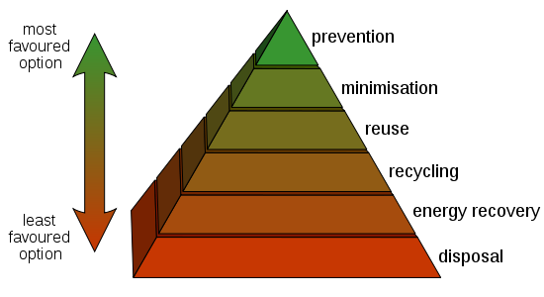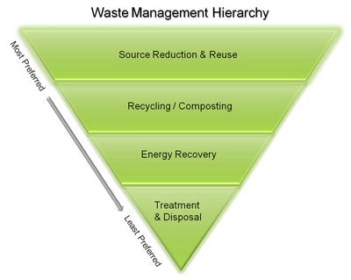

Especially as statewide recycling organization (RO) leaders, we must intentionally speak the right words to the right audience, paint a vivid picture - be compelling, conscious of each audience’s socio-economic sector and probable related driving values/goals, identifying not just the WIIFM, What’s In It for Me?, but also WDIFI, Where Do I Fit In?, which plays more to the concept of “social norms” and being a part of the collective majority.

Recycling fast became the foundation of Sustainable Resource Management, now known more properly as Sustainable Materials Management (SMM). SMM is an integral part of Zero Waste (ZW) management, a now realistic management approach and goal, as demonstrated by early adopters and business leaders across North America. I was once a Zero Waste disbeliever - I was shocked at NRC in 1997 by the announcement from a representative of Minnesota that they intended to go landfill free in the next 10 years…no landfills??!! How?? After all I’ve learned and seen in the interim, I’m now a zero waste believer and the IRA Board of Directors has stated its public support for ZW goals and management methods.
Recent questions to answer include: Where does recycling fit into the array of Sustainability rating systems, Zero Waste systems? Recycling is an important part of LEED, AASHE-STARS, city ordinance fast tracks, ZW assessment/ratings, and Green Business ratings in Seattle/Portland, Boston, all over CA and many cities/businesses in IL…how can RO’s assist and benefit from these management systems/ratings?

Big picture: development of ROs as Not-for-Profit (NFP) organizations...what is an NFP really? To my understanding an NFP functions and exists completely for the “public good” and often for charitable purposes as well as educational. This, vs. a Trade Association…which often is organized as a NFP but also has as a key part of its mission the fostering of increased capacity and economic development of its industry, along with all the local and state policy support that goes with it.

Levels of RO engagement, stages of development of recycling (or any industry) trade associations include:
1. Professional Network - conference, newsletter, website, peer engagement, some resources/staff?
2. Policy work - self-review and monitor membership makeup, respond and provide services based on membership needs, e.g. local gov't/state policy guidance/interaction, provide status reports, research data, provide related education/outreach, usually have staff to assist
3. Certification/professional training/education – delivered along a spectrum of educational platforms, credential levels, tools, but under a unified set of national learning standards, have staff to assist
The Board of Directors’ roles vs. staff role/s sometimes get blurred but Directors’ primary responsibility is fiscal management of members’ funds and pursuit/implementation of stated goals. If only part time, staff mainly keep the admin boat afloat, keep your public presence current/relevant and help to maintain -grow membership. More sophisticated/better funded ROs can play an active role in statewide/local policy and being an education/certification provider, almost certainly with assistance from full time staff.

IRA is dynamic and morphing; next steps include updating our Strategic Plan to lay out goals/timelines for the next 1-3 years, cognizant of the wide umbrella we provide to re-users, composters, E-scrap processors, C&D processors and of course, traditional materials processors and programs. Below are some IL Recycling Association lessons learned along the way, as an NFP and as an RO just recently well-organized enough to provide some policy leadership and industry Certification/training.
IRA suggests that ROs not rely too heavily on any single funding source, e.g. state agency grants. IRA is currently organized as a 501-C-6 NFP but will soon be forming an additional 501-C-3 foundation, an educational arm to allow for grants from private foundations/donors (one of our “rites of passage”.)
We also suggest that ROs not let recycling laws lay too long. We know from experience that goals within outdated laws will stagnate, become perceived as irrelevant. IRA recently participated in a State Recycling Task Force on the latest markets challenges/collection issues, needed new goals/definitions, etc. Try to spotlight these issues/policies, keep them relatively current, for the sake of our industry across all states.
Update state goals/definitions as much as possible, as often as possible; although recycling hasn’t always been perceived as a critical issue, it actually is because of the Green Jobs our industry provides as well as the valuable resources it saves. It’s best to maintain active policy ties w/interested legislators through local members. We suggest regional membership coordinators and Green Drinks events if nothing else, giving members a reason to connect regionally between meetings or conferences.
It’s useful to assess membership demographics and recruit members from sectors often not well represented, e.g. institutional, large business/manufacturing. It’s also strategic to find piggyback partners for events, especially conference/s, for policy efforts and for sharing education offerings/special programs with mutual benefits for all involved.
Occurring right now in US/No America that ROs should pay attention to/engage in, if at all possible:
- Extended Producer Responsibility (EPR): discussion should be robust, considered in light of viable data from neutral sources and informed input from multiple sectors (EPR has tended thus far, to be very government and corporate dominated); initiate EPR policies with caution, conduct pilots and phased-in implementation with planned, evaluated response and ample room for adjustment as needed

-Dirty MRFs/incineration are intrinsically connected to EPR, are again getting a ‘foothold' in cities across the US, please consider whether/how these facilities may/may not serve short- and long-term recovery and reduction goals; most of these facilities are only financially viable at very large population centers where waste reduction/recycling programs are well established and only the last 10-15% “dregs” or non-recoverable items are sufficient to supply these risky and expensive-to-develop-and-maintain operations-
(One recent, very public example of past dirty MRF-incineration policy gone wrong is Harrisburg, PA)
- The US Recycling Archive is established at University of IL Springfield, please gather/share relevant artifacts, materials and/or oral histories; understand the importance of such an archive (and its central location) to our industry and to future researchers

- GIS map any and all recycling/composting capacity you can - mapping paints a clear picture that will point us in the direction of efficiencies....efficiencies in materials consolidation, re-distribution and shared transportation; in other words, Hub 'n Spoke applied on large scale and whatever reduced economy of scale may make sense locally

- Keep an eye on and SHARE new technology, new methods for collection/processing/transportation, new approaches to public education/engagement, new tools for win-win policymaking. Open-Source sharing and Collaboration is the Best Management Practice (BMP) of now and future for both industry and education! (i.e. needed compost learning standards, SMM glossary, etc.)

We are at a culminating point, experiencing history in the making, both the history of our industry and the evolution of related terminology and professional recognition/credentials. ROs can and should be aware, informing their memberships and engaging actively whenever possible. Through ROC and regional groups like MACRO, ROs can learn from and emulate each other, cooperate to hold mutually beneficial events and share BMPs for day-to-day tasks, as well as major planning. Together, we are making a huge collective impact on the US economy and our own state residents’ lives. Let’s keep that in mind and let others know of our good work as we proceed!

